**Driving Directions Mill Hollow YMCA Camp**

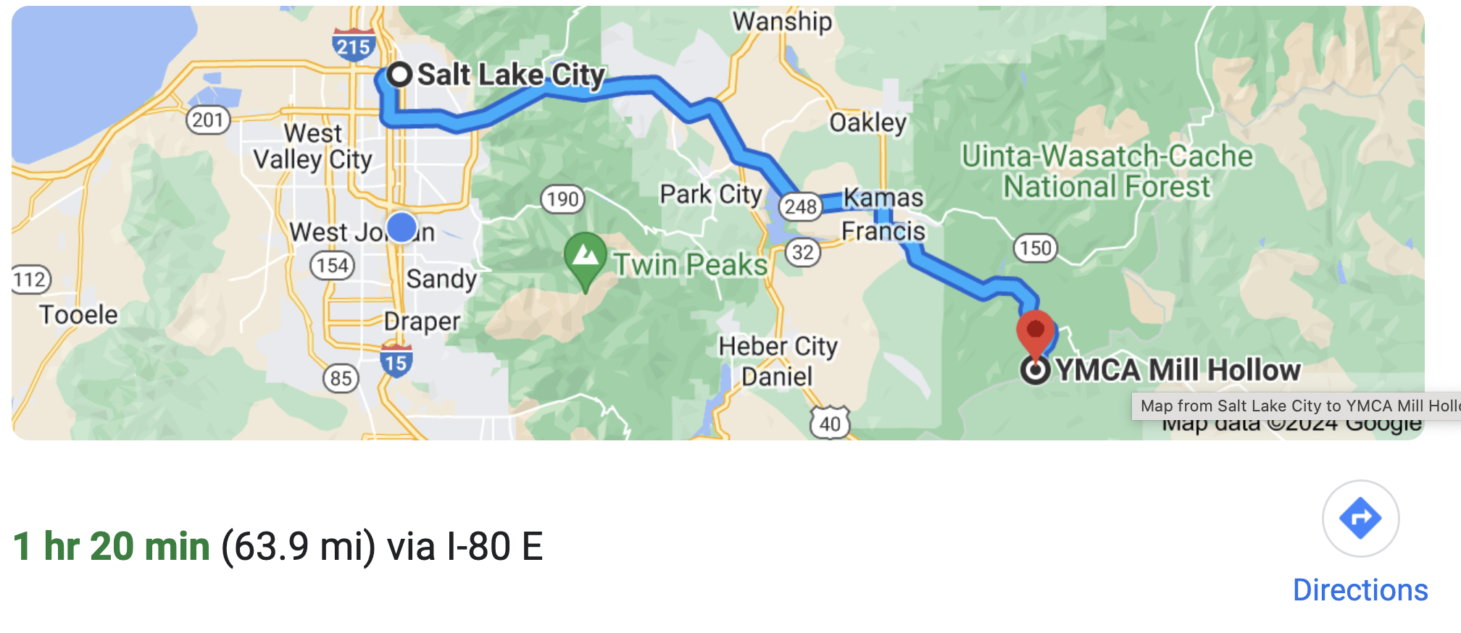Please plan 1 hr and 40 mins as the last 40 mins are on a gravel road. If you are using your GPS search for Mill Hollow YMCA Camp. The Internet stops working when you enter the Unita Forest.

We are changing the location of the Retreat this year due to construction at YMCA Camp Rodgers. Look for WBBR Signs along the way to light your path. Please arrive before dark to make the journey more pleasant. We do have solar lights on our WBBR signs to help those who will be traveling in the dark.

* Take Parleys Canyon toward Park City and take the Heber exit
* Take Exit 4 to Kamas. Turn left and continue into Kamas until you reach the main street where you turn right at the 7-11 Exxon gas station onto SR 248 toward Francis and Heber City
* Continue through Francis a couple of miles until the red flashing stop light
* Turn left entering into the Uintah National Forest and continue for approximately 15 miles.
* “Watch closely for mile marker 15”
* Follow the mile markers until you see “15” and the sign “Mill Hollow Reservoir” YMCA Camp Mill Hollow
* Turn Right and travel 15 miles up the dirt road where you will come to a fork in the road and a sign that says YMCA Mill Hollow. Follow the road to the LEFT
* Continue on the dirt road until you see the YMCA Camp Mill Hollow sign. You can turn Right or Left as follows:
  + **Turn Right**: Delivery Services Road will be used to drive up to the cabins and unload your gear and any food deliveries from the staff
  + **Turn Left:** General Parking Road where you can park and walk up to the cabins and main lodge area. Use this parking lot to park your car after unloading it
  + **Note:** You must unload your vehicle and then drive down to the lower parking area to park